FOR IMMEDIATE RELEASE
“That’s Opportunity Knocking”

WINNER of
12 Festival
Awards

“The keen ensemble performances make this funny production hilarious.” Huffington Post

“Brilliant writing that is perfectly performed by an extremely strong cast.”
Movie-Blogger.com

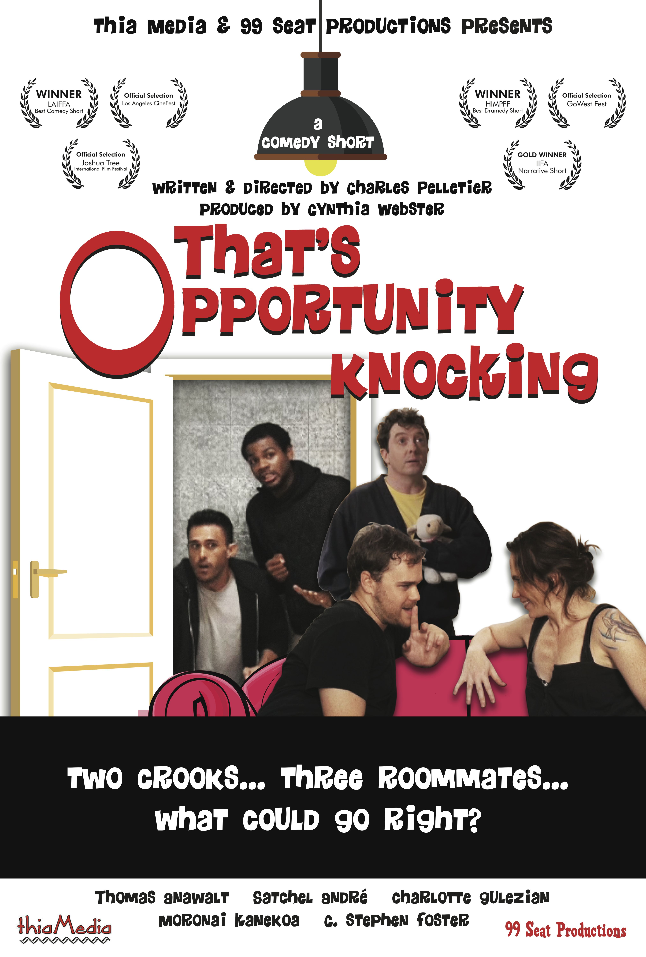

Based loosely on true events, Thia Media and 99 Seat Productions present the comedy short, “That’s Opportunity Knocking”. Emmy-winning producer/cinematographer Cynthia Webster joins forces with award-winning writer/director Chuck Pelletier to create a hilarious take on a real life unsolved crime.

- Winner Best Comedy, Best Screenplay, Best Supporting Actor, Stephen Foster at WWA Film Fest
- Winner Best Comedy & Best Performance by a cast at KaPow Intergalactic Film Festival
- Winner Best Comedy Scene at Action on Film
- Winner Jury Award at Go Independent Film Festival DC
- Winner Best Comedy Short at LAIFFA
- Winner runner-up: Best Comedy at GoWest Film Fest
- Winner Best Supporting Actor Moronai Kanekoa at International Filmmaker Festival of World Cinema London
- Winner Best Comedy-Dramedy at HIMPFF

Featuring award-winning/critically acclaimed cast Thomas Anawalt, Satchel Andre, Charlotte Gulezian, Moronai Kanekoa and C. Stephen Foster.

View Trailer & MORE information:

www.thatsopportunityknockingthemovie.com

CONTACT: Charles Pelletier thatsopportunityknocking@gmail.com

