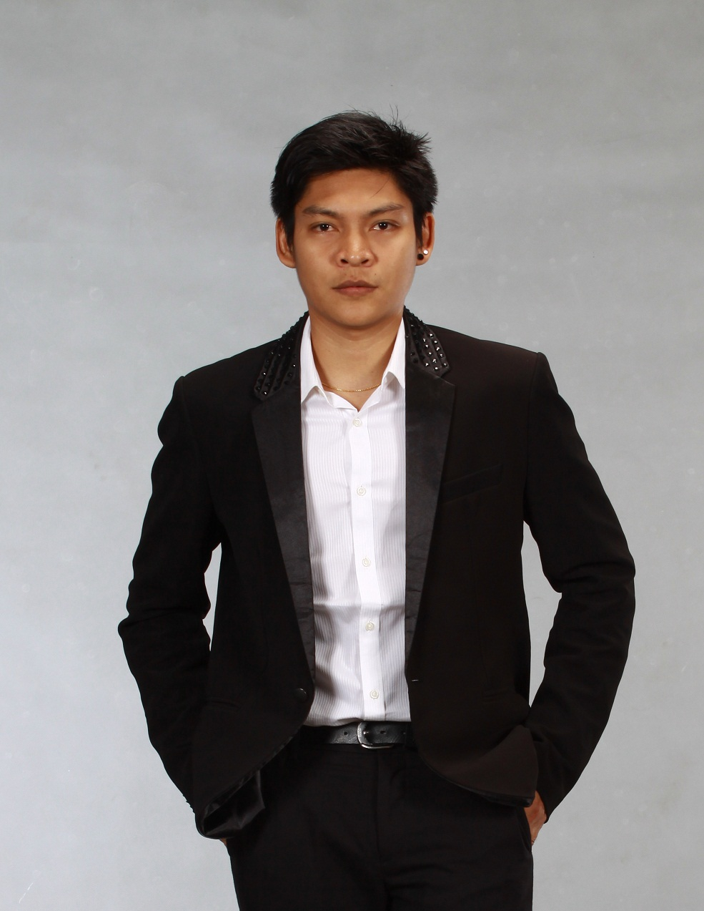
Director’s Biography
Mr. SEIN LYAN TUN
MANAGING DIRECTOR
PS-Perfect Services
Founder
PS Myanmar Group
BLK 27, ,#06, Mahar Myit Mo Street, South Sayar San Quarter, Bahan Township, Yangon
Mobile No: 095321312
E-mail: seinlyantun@gmail.com

SEIN LYAN TUN has a vast experiences working abroad as well as in local, hopes to contribute to the community especially those in needs. His passion on contributing and helping the community does not stop when he was away from Myanmar. He helps his country mates by organizing theatres, and talk shows to build the camaraderie among Myanmar nationals. His passion of helping and contributing is beyond words and will never stop.

SEIN LYAN TUN graduated from University of Foreign Languages Yangon Myanmar in Bachelor of Arts (French) from 2000 to 2004. The following year, he continued his education in Computer Art Design Diploma course in University of Culture. His interest in acquiring knowledge in other field has pushed him to take a Diploma course in Accounting, LCCI Level III, UK.
When he was in Europe (CYPRUS), he worked in the field of designing, printing and social service, where he deals and manages with various clients from different backgrounds and expectations. Sein Lyan Tun, over the 9 years of working in Cyprus and Singapore, has never fails to stimulate his ideas on how well he can do more for the community. Working in Singapore as a Director of Operations at STUDENT ADVISORY CENTRE (SAC), SEIN LYAN TUN, manages a team of more than 150 staffs and 200 volunteers to achieve target set by the organization. Sein Lyan Tun went beyond his job scope by conducting group workshop & individual sessions to youth in need and has always been a good encouraging friend and buddy to them. During those years, he studied Executive Master of Science in Industrial Organizational Psychology at Singapore from City University of New York.
With his 3 years working in Social Service sector of Singapore, SEIN LYAN TUN wants to make a difference in Myanmar by initiating the pilot project of HOPE AND CHILDREN’ WISH. It is hoped that through this pilot project, students in Myanmar will be more receptive and forthcoming in equipping themselves not only in Academic field but also in social emotional skills that develop them into a better individuals in the future.
Currently, SEIN is going around the cities and giving Motivation workshop to students in different kinds of schools. SEIN is talking part of Human Right Human Dignity International Film Festival Project as a Traveling Film Festival Coordinator and youth outreach Program Trainer. SEIN become workshop trainer and training for Communication and Interpersonal skills, Product & Media Concept, Supervisory Skills, Customer Services Skills and Business Management Skills and so on. SEIN is also a Script Supervisor and Program Director for Samsung Scholarship TV Program which is on going on every Saturday show at 4pm MRTV4.

Director’s Filmography

- Youth & Education 5min (Documentary 2013)
- Exit 3 min (Silence Short Film 2013)
- TV Program on MRTV4 National Channel (Samsung Scholarship TV Program since 2014)
- RULA 8 min (Short Film 2015) Official Selected for Human Rights Human Dignity International Film Festival Myanmar
- Charred Brick 15 min (Documentary 2015) Official Selected for Human Rights Human Dignity International Film Festival Myanmar

